CLOTHING CONSULTANT BOT



|  |  |  |  |
| --- | --- | --- | --- |
| **VERSION NO.** | **EFFECTIVE DATE** | **DESCRIPTION OF CHANGE** | **PREPARED BY** |
| 1 | 12th Aug 2025 | First Draft | Vimala S |
|  |  |  |  |

INDEX

|  |  |  |
| --- | --- | --- |
| **Sr. No** | **CONTENT** | **Pg. No** |
| 1 | Objective | 3 |
| 2. | Required Software & Access | 3 |
| 3. | Flowchart | 3 |
| 4. | Business Flow | 4 |

## **OBJECTIVE:**

The **Clothing Consultant Bot** is designed to recommend suitable clothing based on the current weather conditions in a user-specified city.  
Using web automation in **UiPath**, the bot retrieves live weather data and temperature from Google Search and suggests appropriate outfits (e.g., warm clothing for cold weather, light attire for hot weather)

## **REQUIRED SOFTWARE & ACCESS:**

* 1. Microsoft Edge Browser
  2. Google Account (optional – for saved settings)
  3. UiPath Studio with Edge Extension enabled

## **FLOWCHART:**

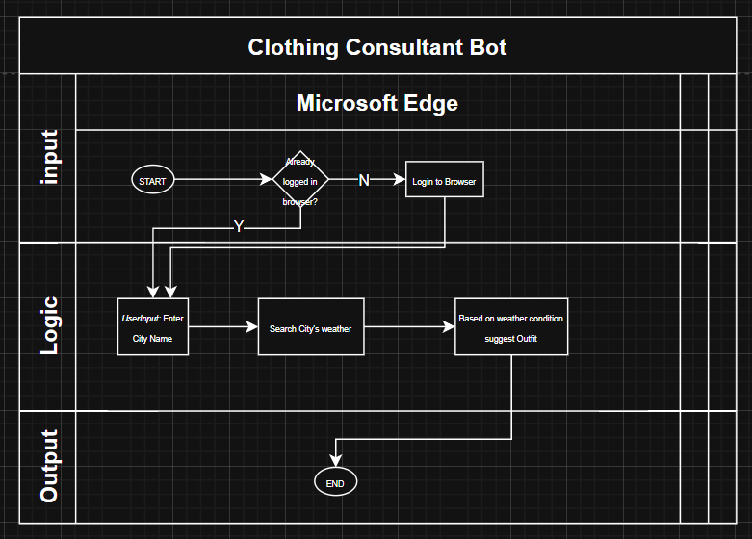

## **BUSINESS FLOW:**

|  |  |  |
| --- | --- | --- |
| **STEP NO.** | **ACTION** | **SCREENSHOTS** |
| 1 | User inputs the name of the city for which they want the clothing suggestion. |  |
| 2 | Bot launches Microsoft Edge, navigates to **google.com**. |  |
| 3 | Bot searches "Weather in <City Name>" and retrieves temperature and condition. |  |
| 4 | Extracts key weather info (e.g., temperature, condition – sunny, rainy, snowy, cloudy).  If –  Temp < 40: Cold  Temp > 80: Hot  Temp >=40 &&<=80: Warm. |  |